

Riccardo Cobianchi 2017/2018

10602451

898223

Open Studio Project

*Introduction*

The purpose of this project is to evaluate the different loads on a building with different wall composition and compare the results for the same construction situated in different thermal zone.

*Software and Methodology*

For this calculations Open Studio and Sketch up are being used.

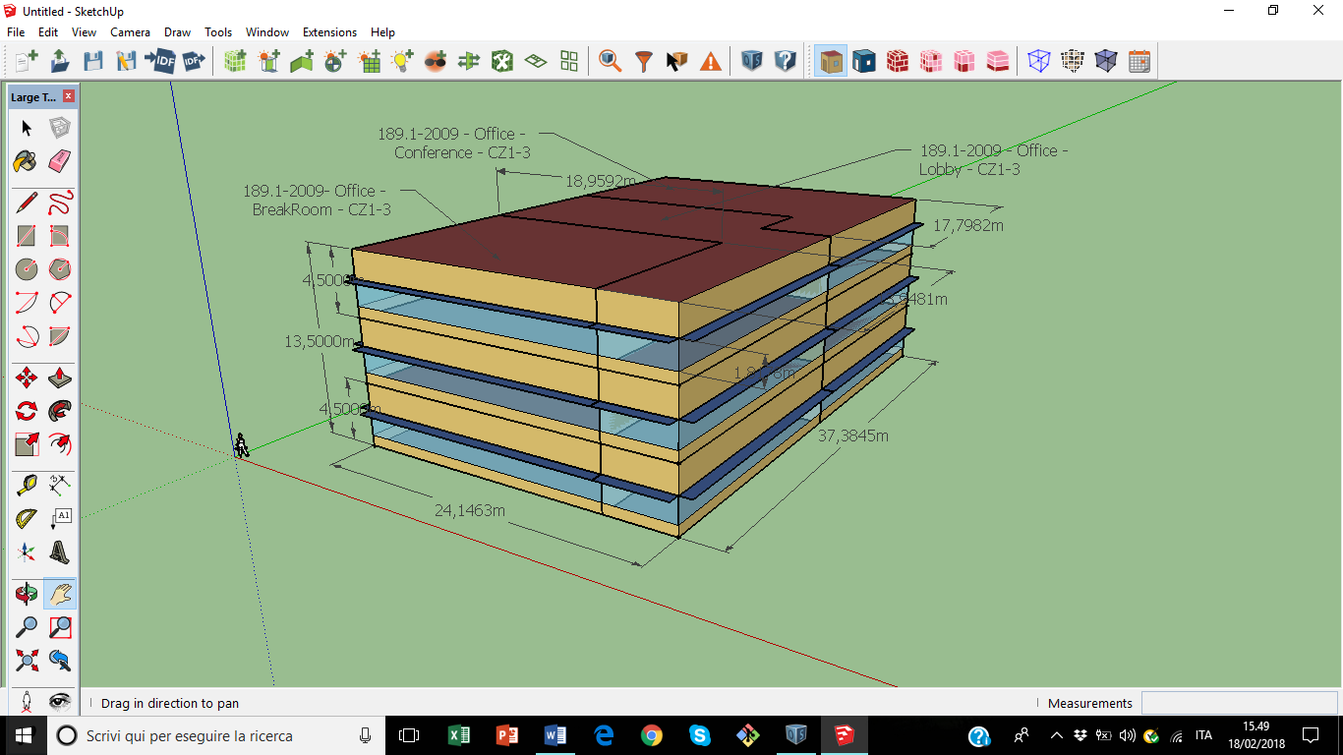

Main parameters of the building

The graph shows the main components of the construction with the reference measures. The inner conditions and the arrangement of the rooms is the same for each floor.

* Division of the Floor

A) 189.1-2009 – Office – Breakroom – CZ1-3

Standard 189.1 provides total building sustainability guidance for designing, building, and operating high-performance green buildings. From site location to energy use to recycling, this standard sets the foundation for green buildings by addressing site sustainability, water use efficiency, energy efficiency, indoor environmental quality (IEQ), and the building's impact on the atmosphere, materials and resources.

CZ stands for Climate Zone

B) 189.1-2009 – Office – Lobby – CZ1-3

A) 189.1-2009 – Office – Conference – CZ1-3

* Climate Zone 1 – Country

A) USA_FL_Miami.722020_TMY2

B) PRT_Lisboa.085360_INETI

C) ITA_Piacenza.160840_IGDG

* Stratified Division of the Wall

*A) ASHRAE 189.1-2009 ExtWall Mass ClimateZone 1*

🡪 1IN Stucco

🡪 8IN Concrete HW

🡪 Wall Insulation 31

🡪 1/2IN Gypsum

*B) New Wall Composition*

🡪 G05 25mm Wood 1

🡪 Wall Insulation 31 1

🡪 MAT-CC05 4 HW Concrete 1

🡪 1/2IN Gypsum 2

*C) New Wall Composition 2*

🡪 1IN Stucco

🡪 F08 Metal Surface

🡪 1/2IN Gypsum 4

🡪 G05 25mm Wood 1

*Calculation*

Starting Using SketchUp

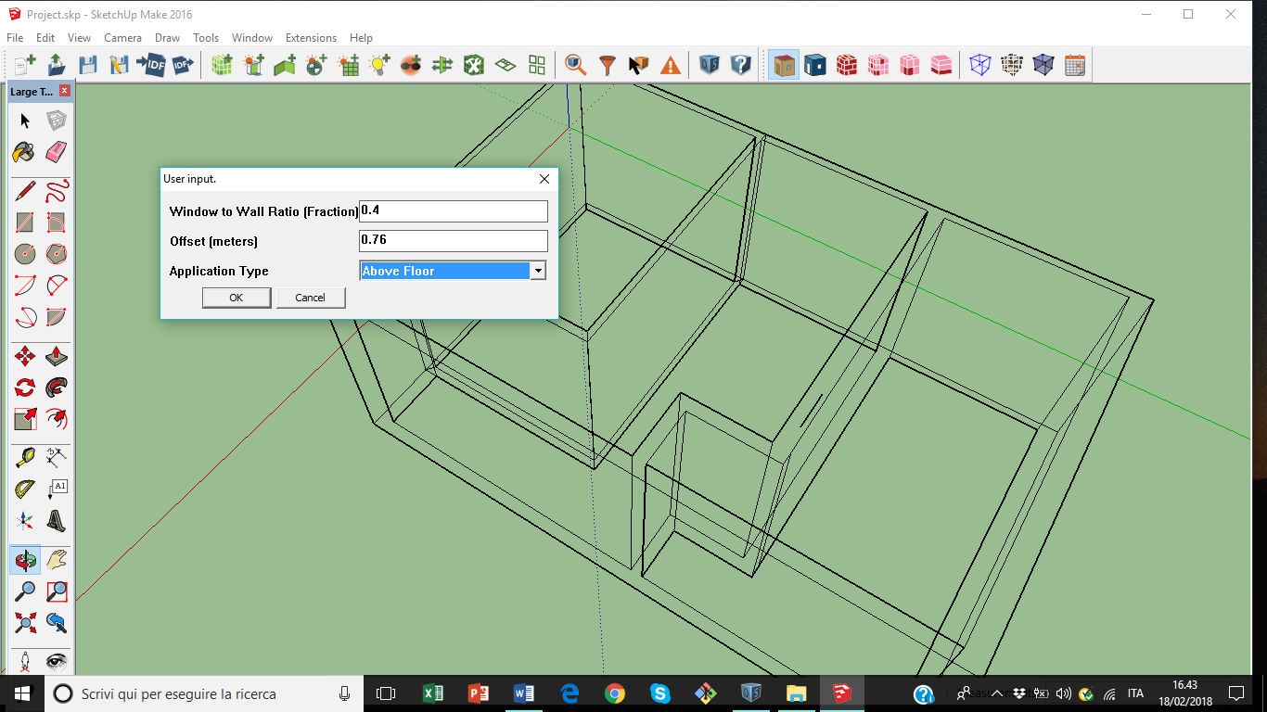

User Input for the Windows

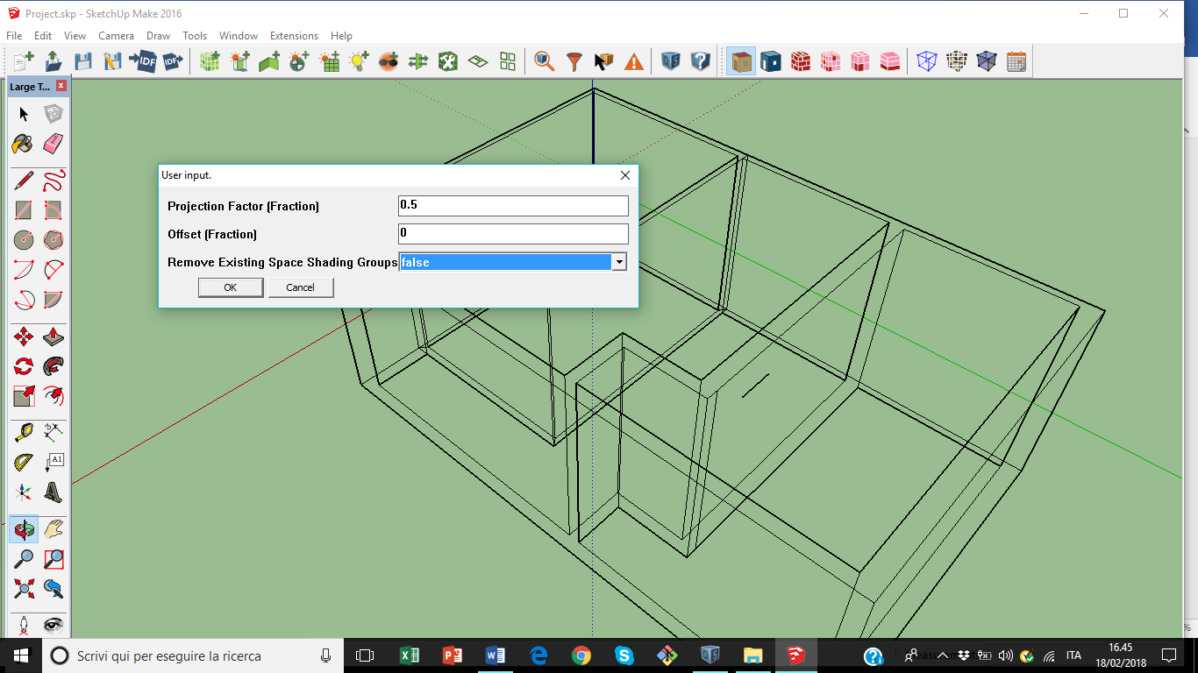

User Input - Shading

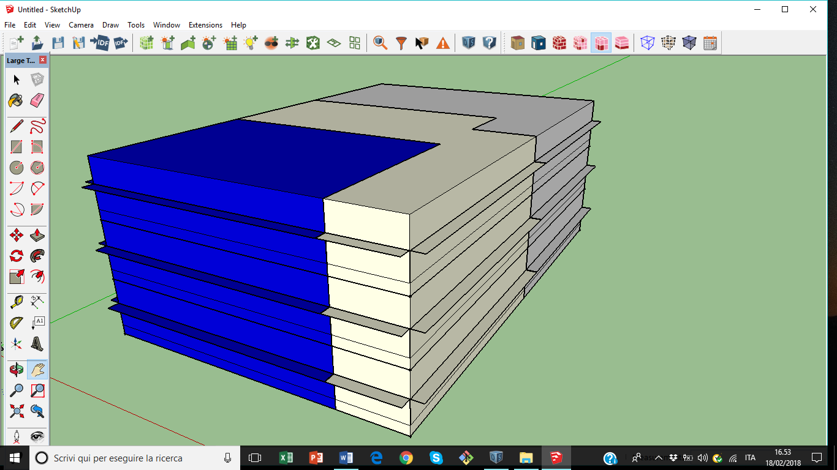

Different Colours for each Thermal Zone

*Starting Using Open Studio*

First Step 🡪 Insert the weather data after running the programme.

All the information about the climate condition could be found in the link below:

https://energyplus.net/weather

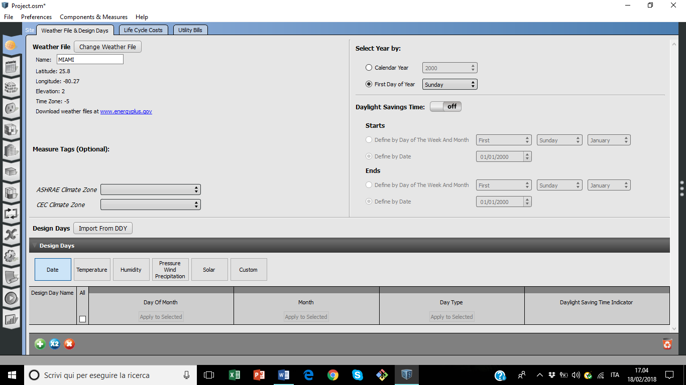

Second Step 🡪 In this part we can change the wall composition.

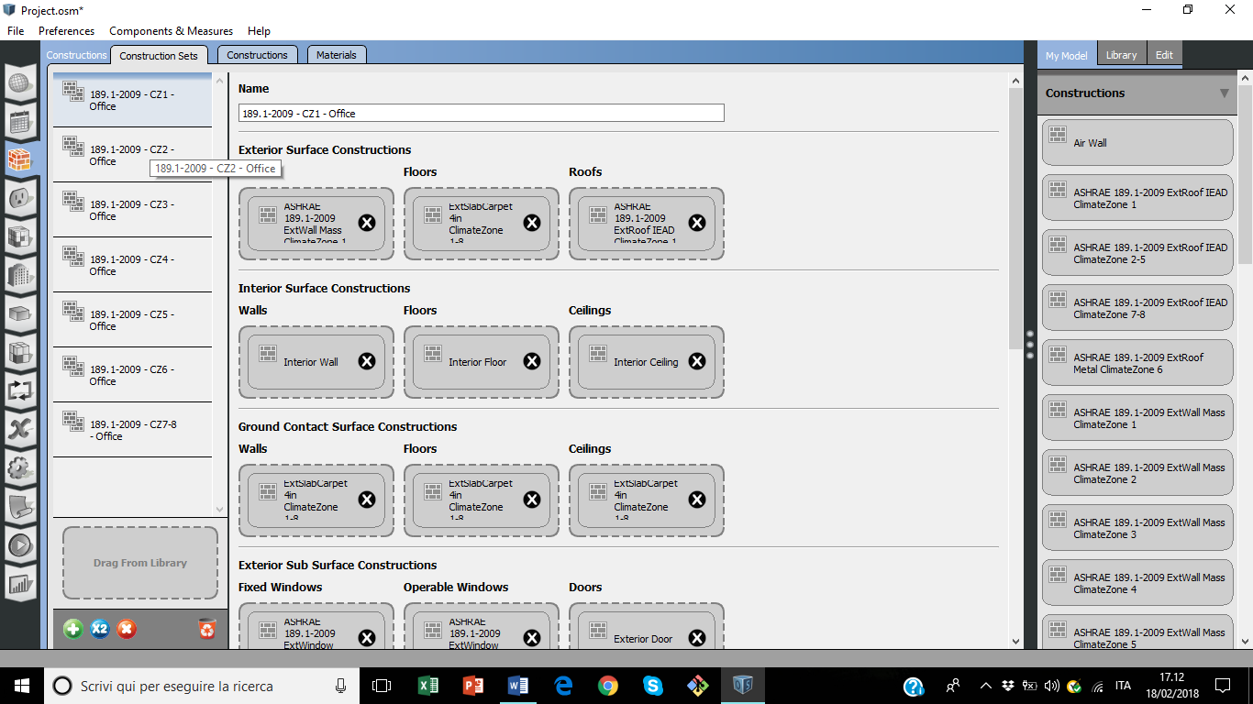

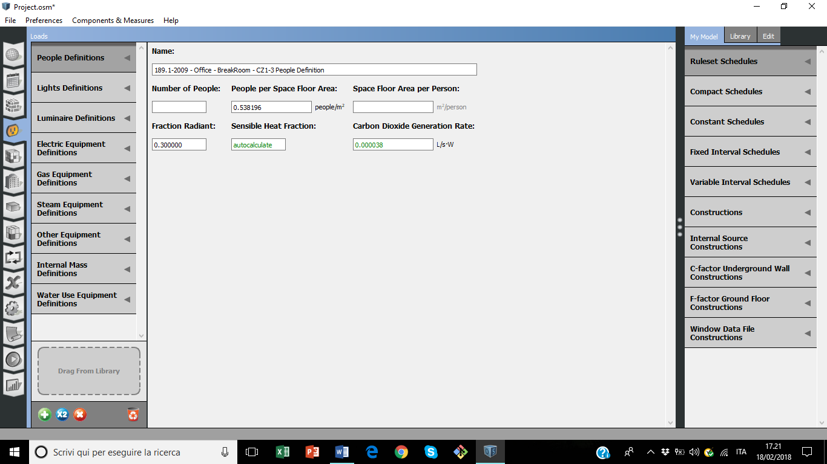

The number of people per Space Floor Area changes according to the Room’s “Application”. For this aim I have maintained constant the default value of the program. Also, in “Light Definitions” the Energy per Space Floor Area in correlated to the Space Definition and it is maintained as the default value.

*Final Report*













*Conclusion*

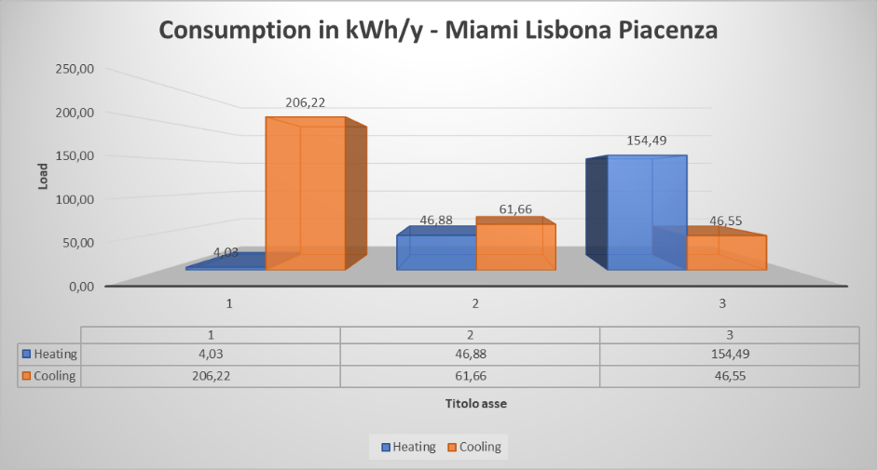

The graph shows us how the cooling and heating loads varying according to the ambient weather in different countries. Obviously for Miami City we obtain the higher value for cooling load, that differs from Piacenza, in which we have an higher value of heating load.

In the case of Lisbona (Portugal) heating and cooling loads are quite similar during the year period.